

Tender Management Process©
For [Project Name]

Document Control

Document Information
© | Information
Document Id | [Document Management System #]
Document Owner | [Owner Name]
Issue Date | [Date]
Last Saved Date | [Date]
File Name | [Name]

Document History
Version | Issue Date | Changes
[1.0] | [Date] | [Section, Page(s) and Text Revised]

Document Approvals
Role | Name | Signature© | Date
Project Sponsor

Project Review Group

Project Manager©

Quality Manager
(if applicable)

Procurement Manager
(if applicable)

Communications Manager
(if applicable)

Project Office Manager
(if applicable)

Table of Contents

Template Guide 1
1 Tender Process 2
1.1 Overview 2
1.2 Issue RFI 3
1.2.1 Document “Statement of Work” (SOW) 3
1.2.2 Document “Request for Information” (RFI) 3
1.2.3 Release Tender Documents (RFI & SOW) 3
1.2.4 Receive and Evaluate Tender Responses 3
1.2.5 Select Tender Shortlist and Notify Suppliers 3
1.3 Issue RFP 4
1.3.1 Update “Statement of Work” (SOW) 4
1.3.2 Document “Request for Proposal” (RFP) 4
1.3.3 Release Tender Documents (RFP & SOW) 4
1.3.4 Receive and Evaluate Tender Responses 4
1.3.5 Select Preferred Tender and Notify Suppliers 4
1.4 Issue Contract 5
1.4.1 Document Supplier Contract 5
1.4.2 Negotiate Supplier Contract 5
1.4.3 Sign Supplier Contract 5
2 Tender Roles 5
2.1 Procurement Manager / Officer 5
2.2 Project Manager 6
3 Tender Documents 6
3.1 Statement of Work (SOW) 6
3.2 Request for Information (RFI) 6
3.3 Request for Proposal (RFP) 6
3.4 Supplier Contract 6
3.5 Tender Register 6

Template Guide

What is a Tender Management Process?

A Tender Management Process is a formal method by which potential suppliers are identified, evaluated and selected for the supply of products (goods or services) to the project. The process entails the creation of a suite of tender documentation outlining the project requirements, receiving tender responses and selecting preferred suppliers, based primarily on the quality of their response. A Tender Management Process is used to ensure that the selection of preferred suppliers occurs in a fair and honest manner. ©

Although a number of types of Tender Management processes exist, this document provides a worked example of one particular type of tender process: the RFI / RFP process. This involves:
- Issuing a Statement of Work (which describes the project requirements)
- Issuing a Request for Information (requesting general supplier information)
- Issuing a Request for Proposal (requesting detailed supplier proposals)
- Receiving and evaluating each response, based on its merits
- Choosing a preferred supplier, based on his/her merits
- Negotiating a formal contract with the preferred supplier.

When to use a Tender Management Process

A Tender Management Process should be utilized whenever a product is required from outside the project and a preferred supplier has not yet been chosen. The Tender Management Process is initiated immediately after the Procurement Plan has been approved. The Tender Process is usually undertaken by the delegated Procurement Manager (or officer); however, for large projects a Tender Committee may be formed to oversee the tender process.

Without a formal Tender Management Process in place, it may not be possible to show that the method by which preferred suppliers were selected was rigorous and fair. The Tender Management Process is terminated only when the preferred suppliers have been selected and the supplier contracts formally signed. ©

How to use this template

This document provides a guide on the topics usually included in a Tender Management Process. Sections may be added, removed or redefined at your leisure to meet your particular business circumstance. Example tables, diagrams and charts have been added (where suitable) to provide further guidance on how to complete each relevant section.

Tender Process

Describe in detail the process undertaken to identify, evaluate and select preferred suppliers for the acquisition of product for the project.

Overview
Provide an overview of the Tender process for the project. For example: “The purpose of the Tender Process is to provide a clear, robust and fair process for the appointment of preferred suppliers for the acquisition of product for the project. In summary, the Tender Process will be undertaken by this project through the implementation of three key processes:
- Issue RFI
- Issue RFP
- Issue Contract. ©

The following diagram describes the processes and procedures required to select a preferred supplier for the project.

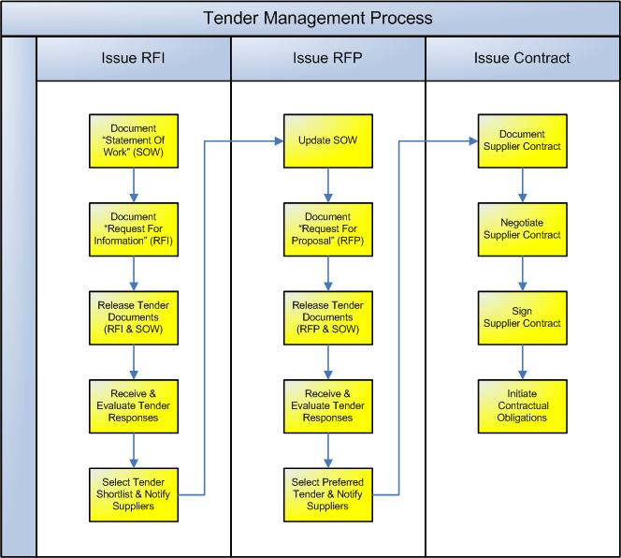

Issue RFI

The first tender process undertaken is to issue an RFI to the market place. This document requests that interested suppliers respond to the tender document by providing summary information describing their organization, the products they sell and their approach to procurement. The following procedures are undertaken: ©

    - Document “Statement of Work” (SOW)
Before a tender document is released, it is important to define the requirements of the project. The SOW outlines the following types of supplier requirements:

- Company (size, industry)
- Product (type, number of years available)
- Training (level required)
- Documentation (provided with product)
- Support (available for product)
- Schedule (for delivery of product)
- Reporting (regarding product delivery)
- Pricing (of product)
- Confidentiality (for product).

    - Document “Request for Information” (RFI)
Once the SOW has been defined, an RFI is produced. The purpose of the RFI is to identify interested suppliers in the market place and find out basic information regarding their business and product-set. This information is then used to determine whether or not the supplier is likely to meet the requirements of the project as outlined in the SOW. The RFI is documented by the project team and approved by the Project Manager.

    - Release Tender Documents (RFI & SOW)
The RFI and SOW are released to the marketplace to inform potential suppliers of the project requirement as outlined within the SOW and the format of the required response as outlined in the RFI. A set of timeframes is explicitly provided for the supplier to formulate a response and send it to the project team for review. ©

    - Receive and Evaluate Tender Responses
Once the Response period has expired, the Procurement Manager (or Officer) collates the responses received from interested suppliers and logs their details in the Tender Register. The tender responses are then formally evaluated. One of a number of evaluation methodologies may be used to select the tender shortlist; however, it is usual for responses to be rated according to pre-defined criteria and weighted according to their rating category.

    - Select Tender Shortlist and Notify Suppliers
The responses with the highest scores are added to a tender shortlist. Only short-listed suppliers will have the opportunity to take part in the next phase of the tender process: the RFP phase. Suppliers who are not on the short-list are formally notified that they will not be progressing to the next phase.

Issue RFP
The next tender process undertaken is to issue an RFP to the short-listed RFI suppliers. This document requests that short-listed suppliers respond to the tender document by providing detailed information describing their organization, the products they sell and their approach to meeting the needs of the project. The following procedures are undertaken: ©

    - Update “Statement of Work” (SOW)
Based on the responses to the RFI, the project team will have become more aware of the potential suppliers and products available in the marketplace, in addition to the information sourced already during the market research exercise. This information may be used to review the SOW document and update the requirements, based on what is now thought available and possible. For instance, a supplier may have suggested a new technology (or approach) previously not thought of. NB The team must be careful not to redefine the SOW based on only one supplier response; otherwise they may pre-determine the overall result of the tender process.

    - Document “Request for Proposal” (RFP)
Once the SOW has been updated, an RFP is produced. The purpose of the RFP is to gather more detailed information from each supplier regarding their company, products and approach to the procurement requirement. This information is used to determine whether or not the supplier meets the detailed requirements set out by the SOW. The RFP is documented by the project team and approved by the Project Manager for release to the short-listed suppliers. ©

    - Release Tender Documents (RFP & SOW)
The RFP and SOW are released to the short-listed suppliers to inform them of the detailed project requirements and format of the required response. As per the RFI process, the timeframe for formulating and submitting the supplier response is also made explicit.

    - Receive and Evaluate Tender Responses
Once the Response period has expired, the Procurement Manager (or Officer) collates the responses received from the short-listed suppliers and updates their details in the Tender Register. The tender responses are then formally evaluated, using more detailed criteria than the RFI evaluation process.

    - Select Preferred Tender and Notify Suppliers
The single response with the highest score is then selected as the preferred supplier and asked to enter the contract negotiation phase. All other suppliers are formally notified that they will not be progressing to the next phase. NB While it is usual to have only one preferred supplier, it is possible to choose 2 or more preferred suppliers if they can meet the particular needs of the project.

Issue Contract
The final phase of the tender process is the negotiation of the supplier contract. The contract forms the basis of the relationship and specifies the terms and conditions surrounding the delivery of the product by the supplier to the project. The following procedures are undertaken: ©

    - Document Supplier Contract
A formal supplier contract is drafted by the project team for the delivery of supplier product which meets the requirements laid out in the SOW.

    - Negotiate Supplier Contract
The Procurement Manager and supplier representative then negotiate contractual conditions which they believe to be fair and reasonable and a final draft is drawn up for approval. At this point, legal council should be sought to ensure that the document does not put the project at risk and that it will deliver the benefits required by the project.

    - Sign Supplier Contract
The Project Manager and supplier representative then authorize the contract by formal signature. The contract is filed and the formal obligations under the contract for the supply of product are commenced under the Procurement Management Process.
(NB Refer to the Method123 ‘Procurement Management Process’ template for a complete example).

Tender Roles

Define the roles and responsibilities for all resources (both internal and external to the project) involved with the Tender Management Process. Examples include:

Procurement Manager / Officer
The Procurement Manager (or Officer) is responsible for ensuring that the entire Tender Management process is executed as defined by this document. This includes:

- Drawing up the SOW, RFI and RFP documents
- Obtaining approval to release the SOW, RFI and RFP documents to potential suppliers
- Collating the tender responses and organizing a Tender Review Committee (if required)
- Organizing the tender evaluation process and working with the Project Manager to ensure that the short-listed and preferred supplier(s) is/are chosen fairly
- Notifying unsuccessful candidates that they will not be progressing further
- Documenting the draft Supplier contract and leading supplier negotiations
- Finalizing the supplier contract and ensuring that legal council has been sought
- Keeping the Tender Register up to date at all times. ©

Project Manager
The Project Manager acts as a checkpoint to ensure that the Tender Management Process is undertaken efficiently and fairly by:

- Approving the SOW, RFI and RFP tender documentation prior to its release
- Managing the tender evaluation process and approving the preferred supplier selection
- Resolving contractual negotiation issues and authorizing the final supplier contract. ©

Tender Documents

Reference any other documentation used during the Tender Management Process.

Statement of Work (SOW)
The SOW outlines the procurement requirements of the project which must be met by the supplier. In addition to the requirements for the supply of product, other types of requirements may include training, documentation and support.
(NB Refer to the Method123 ‘Statement of work (SOW)’ template for a complete example).

Request for Information (RFI)
The RFI is a document which is issued to the market-place requesting that interested suppliers provide basic information outlining how their business and product-set can meet the generic requirements of the SOW.
(NB Refer to the Method123 ‘Request for Information (RFI)’ template for a complete example).

Request for Proposal (RFP)
The RFP is a document which is issued to RFI short-listed suppliers requesting that detailed information be provided outlining how their business and product-set can meet the detailed requirements of the SOW.
(NB Refer to the Method123 ‘Request for Proposal (RFP)’ template for a complete example).

Supplier Contract
The Supplier Contract is the formal document which outlines the terms and conditions for the supply of products by the preferred supplier to the project team. ©
(NB Refer to the Method123 ‘Supplier Contract’ template for a complete example).

Tender Register
The ‘Tender Register’ is the log / database where all tender responses are registered and tracked through to completion.
(NB Refer to the Method123 ‘Tender Register’ template for a complete example).

